**The Gaming Site (5 Minute Smash)**

**A PROJECT REPORT**

**for**

**Mini Project (KCA353)**

**Session (2024-25)**

**Submitted by**

**Kapil Maheshwari**

**(2300290140085)**

**Kavya Verma**

**(2300290140087)**

**Hritik Chaudhary**

**(230029014077)**

**Prabal Pratap Singh**

**(230029014119)**

**Submitted in partial fulfilment of the**

**Requirements for the Degree of**

**MASTER OF COMPUTER APPLICATION**

**Under the Supervision of**

**Dr. Akash Rajak**

**Professor**



**Submitted to**

**Department Of Computer Applications**

**KIET Group of Institutions, Ghaziabad**

**Uttar Pradesh-201206**

**(DECEMBER 2024)**

# CERTIFICATE

Certified that **Kapil Maheshwari (2300290140085), Kavya Verma (2300290140087), Hritik Chaudhary (230029014077), Prabal Pratap Singh (230029014119)** have carried out the project work having “**The Gaming Site (5 Minute Smash)**” (**Mini Project-KCA353**) for **Master of Computer Application** from Dr. A.P.J. Abdul Kalam Technical University (AKTU**)** (formerly UPTU), Lucknow under my supervision. The project report embodies original work, and studies are carried out by the student himself, and the contents of the project report do not form the basis for the award of any other degree to the candidate or to anybody else from this or any other University/Institution.

This is to certify that the above statement made by the candidate is correct to the best of my knowledge.

|  |  |
| --- | --- |
| **Dr. Akash Rajak**  **Professor**  **Department of Computer Applications**  **KIET Group of Institutions, Ghaziabad** | **Dr. Arun Kumar Tripathi**  **Professor & Dean (CA)**  **Department of Computer Applications**  **KIET Group of Institutions, Ghaziabad** |

**The Game Site (5 Minute Smash)**

Kapil Maheshwari

Hritik Chaudhary

Kavya Verma

Prabal Pratap Singh

# ABSTRACT

The Game Site (5 Minute Smash) is an innovative web-based platform designed to consolidate the online gaming experience into a single, user-friendly interface. As online gaming continues to grow as a prominent form of entertainment, challenges such as fragmentation and the inconvenience of accessing multiple platforms have become increasingly prevalent. This project aims to address these challenges by integrating multiple game genres, robust user authentication, real-time score tracking, and competitive leaderboards within a scalable and responsive framework.

Developed using cutting-edge technologies such as React.js, Node.js, and MongoDB, The Game Site (5 Minute Smash) emphasizes scalability, cross-device compatibility, and robust security. The platform’s layered architecture ensures a seamless user experience while maintaining high performance and flexibility for future enhancements. Features such as personalized user profiles, dynamic notifications, and multiplayer support further enhance user engagement.

This thesis explores the conceptualization, design, implementation, and testing phases of The Game Site (5 Minute Smash). Through a comprehensive analysis of existing platforms and emerging technological trends, the project identifies gaps in current offerings and proposes solutions to bridge them. Testing methodologies, including functional and performance tests, have validated the platform’s reliability, security, and user satisfaction.

The Game Site (5 Minute Smash) sets a foundation for future innovations, including the integration of augmented and virtual reality games, AI-driven recommendations, and advanced analytics to understand user behavior. By addressing existing pain points and introducing new capabilities, The Game Site (5 Minute Smash) demonstrates its potential to redefine the online gaming landscape, catering to both casual gamers and competitive players alike. This document provides a detailed account of the development journey, results, and prospects for this transformative platform.

# ACKNOWLEDGEMENT

Success in life is never attained single handedly. My deepest gratitude goes to my thesis supervisor, Dr. Akash Rajak, Professor for their guidance, help and encouragement throughout my project work. Their enlightening ideas, comments, and suggestions have guided me a lot in completing this project successfully.

Words are not enough to express my gratitude to Dr. Arun Kumar Tripathi, Professor and Head, Department of Computer Applications, for his insightful comments and administrative help on various occasions. Fortunately, I have many understanding friends, who have helped me a lot with many critical conditions.

Finally, my sincere thanks go to my family members and all those who have directly and indirectly provided me with moral support and other kind of help. Without their support, completion of this work would not have been possible in time. They keep my life filled with enjoyment and happiness.

|  |
| --- |
| **Kapil Maheshwari (2300290140085)** |
| **Kavya Verma (2300290140087)** |
| **Hritik Chaudhary (230029014077)** |
| **Prabal Pratap Singh (230029014119)** |

# TABLE OF CONTENTS

CERTIFICATE ii

ABSTRACT iii

ACKNOWLEDGEMENT iv

TABLE OF CONTENTS List of Tables v

List of Tables ix

LIST OF FIGURES x

CHAPTER 1 INTRODUCTION 1

1.1 Overview 1

1.2 Problem Statement 1

1.3 Objectives 1

1.4 Scope 2

CHAPTER 2 FEASIBILITY STUDY 3

2.1 Economic Feasibility 3

2.1.1 Development Costs 3

2.1.2 Operational Costs 3

2.1.3 Revenue Generation 3

2.2 Technical Feasibility 3

2.2.1 Technology Stack 3

2.2.2 Integration 3

2.2.3 Security 4

2.2.4 Cross-Device Compatibility 4

2.3 Operational Feasibility 4

2.3.1 User Adoption 4

2.3.2 Maintenance and Support 4

2.3.3 Scalability 4

CHAPTER 3 SOFTWARE REQUIREMENT SPECIFICATION (SRS) 5

3.1 Functionalities 5

3.1.1 User Authentication: 5

3.1.2 Game Selection and Launch: 5

3.1.3 Real-Time Score Tracking: 5

3.1.4 Leaderboards: 5

3.2 User Characteristics 5

3.2.1 Players: 6

3.2.2 Administrators: 6

3.3 Features 6

3.3.1 Secure Login System: 6

3.3.2 Game Categorization: 6

3.3.3 Persistent Storage of Scores: 6

3.3.4 Multiplayer Functionality: 6

3.3.5 Customizable User Profiles: 6

3.3.6 Real-Time Notifications: 6

3.4 System Requirements 6

3.4.1 Hardware Requirements: 6

3.4.2 Software Requirements: 7

CHAPTER 4 SYSTEM REQUIREMENTS 8

4.1 Functional Requirements 8

4.1.1 User Registration and Login 8

4.1.2 Game Database Management 8

4.1.3 Game Launching and Playability 8

4.1.4 Score Tracking and Leaderboards 8

4.1.5 Administrator’s Controls 8

4.2 Non-Functional Requirements 9

4.1 Performance 9

4.2 Scalability 9

4.3 Reliability 9

4.4 Security 9

4.5 Usability 9

4.6 Compatibility 9

4.7 Maintainability 9

4.8 Compliance 9

CHAPTER 5 GAME DESCRIPTIONS 11

5.1 Bubble 11

5.2 Candy 12

5.3 Chess 13

5.4 Connect Four 14

5.5 Doodle Jump 15

5.6 Flappy Bird 16

5.7 Rock-Paper-Scissors 17

5.8 Simon 18

5.9 Sudoku 19

5.10 Tic-Tac-Toe 20

5.11 Whack Mole 21

CHAPTER 6 SYSTEM DESIGN 22

6.1 Primary Design Phase 22

6.1.1 Modules Design: 22

6.1.2 Data Flow: 22

6.2 Secondary Design Phase 22

6.2.1 Database Design: 23

6.2.2 API Design: 23

6.2.3 Algorithm Design: 23

6.2.4 User Interface Design 23

6.3 Database Design 24

6.3.6 Database Overview 24

6.3.7 Entity-Relationship Diagram 24

6.3.8 Database Tables 26

6.3.9 Data Flow and Security 26

CHAPTER 7 ARCHITECTURE 27

7.1 Layered Architecture 27

7.1.1 Presentation Layer 27

7.1.2 Business Logic Layer (Application Layer) 27

7.1.3 Data Access Layer (Persistence Layer) 28

7.1.4 Data Flow 28

7.1.5 System Components 28

7.2 Advantages of Layered Architecture 29

7.2.7 Modularity 29

7.2.8 Scalability 29

7.2.9 Security 29

7.2.10 Maintenance 29

CHAPTER 8 SCREENSHOTS AND DEMONSTRATIONS 30

8.1 Login Page 30

8.2 Game Catalog 31

8.3 Gameplay Interface 31

8.4 Leaderboard Page 32

8.5 Bubble Gameplay 32

8.6 Candy Gameplay 33

8.7 Chess Gameplay 33

8.8 Connect Four GAMEPLAYS 34

8.9 Doodle Jump Gameplay 34

8.10 Flappy Bird Gameplay 35

8.11 Rock-Paper-Scissors Gameplay 35

8.12 Simon Gameplay 36

8.13 Sudoku Gameplay 36

8.14 Tic-Tac-Toe Gameplay 37

8.15 Whack Mole Gameplay 37

CHAPTER 9 CONCLUSION 38

CHAPTER 10 REFERENCES 39

# List of Tables

|  |  |  |
| --- | --- | --- |
| Table No. | Name of Table | Page |
| 1.1 | Hardware Requirement | 7 |
| 1.2 | Software Requirement | 7 |

# LIST OF FIGURES

|  |  |  |
| --- | --- | --- |
| Figure No. | Name of Figure | Page No. |
| 5.1 | Screenshot of Bubble Gameplay | 11 |
| 5.2 | Screenshot of Candy Crush Gameplay | 12 |
| 4.2 | Screenshot of Chess Gameplay | 13 |
| 4.3 | Screenshot of Connect Four Gameplay | 14 |
| 4.4 | Screenshot of Doodle Jump Gameplay | 15 |
| 4.5 | Screenshot of Flappy Bird Gameplay | 16 |
| 4.6 | Screenshot of Rock-Paper-Scissors Gameplay | 17 |
| 5.8 | Screenshot of Simon Gameplay | 18 |
| 5.9 | Screenshot of Sudoku Gameplay | 19 |
| 5.10 | Screenshot of Tic-Tac-Toe Gameplay | 20 |
| 5.11 | Screenshot of Whack Mole Gameplay | 21 |
| 6.1 | Entity-Relationship Diagram for The Game Site | 25 |
| 8.1 | Login Page | 30 |
| 8.2 | Game Catalog | 31 |
| 8.3 | Gameplay Interface | 31 |
| 8.4 | Leaderboard Page | 32 |
| 8.5 | Bubble Gameplay | 32 |
| 8.6 | Candy Crush Gameplay | 33 |
| 8.7 | Chess Gameplay | 33 |
| 8.8 | Connect Four Gameplay | 34 |
| 8.9 | Doodle Jump Gameplay | 34 |
| 8.10 | Flappy Bird Gameplay | 35 |
| 8.11 | Rock-Paper-Scissors Gameplay | 35 |
| 8.12 | Simon Gameplay | 36 |
| 8.13 | Sudoku Gameplay | 36 |
| 8.14 | Tic-Tac-Toe Gameplay | 37 |
| 8.15 | Whack Mole Gameplay | 37 |

# CHAPTER 1 INTRODUCTION

## 1.1 Overview

The Game Site (5 Minute Smash) is a web-based platform that provides users with access to multiple games through a single, user-friendly interface. This platform is designed to cater to both casual and competitive gamers by offering a centralized hub for various game genres. The system features functionalities like user authentication, score tracking, leaderboards, and cross-device compatibility to ensure an engaging and seamless experience. Built with modern web technologies, the platform is scalable and can accommodate the addition of new games in the future, making it versatile and future-proof.

## 1.2 Problem Statement

In today’s digital age, online gaming is one of the most popular forms of entertainment. However, users often face challenges in navigating between multiple websites or apps to access different games. This fragmented gaming experience can be time-consuming and inconvenient, reducing overall user engagement. Moreover, maintaining a separate login for each game and tracking progress individually is cumbersome for gamers. There is a clear need for a unified platform that consolidates access to various games while maintaining user progress and providing cohesive experience.

## 1.3 Objectives

The main objectives of The Game Site (5 Minute Smash) are as follows:

* To provide a centralized platform where users can access a variety of games without switching between multiple applications or websites.
* To implement a secure and efficient user authentication system that personalizes the gaming experience.
* To track real-time scores and maintain individual leaderboards for each game, promoting healthy competition among users.
* To ensure scalability, allowing developers to add new games and features effortlessly as the platform grows.
* To create a responsive design that supports seamless functionality across devices such as desktops, tablets, and smartphones.

## 1.4 Scope

The Game Site (5 Minute Smash) aims to serve as a comprehensive solution for gaming enthusiasts of all age groups and skill levels. The platform supports various genres, including puzzles, strategy games, and action games, catering to diverse user preferences. It is designed to provide a simple yet immersive experience by offering intuitive navigation and visually appealing interfaces. With scalability as a core feature, The Game Site (5 Minute Smash) is equipped to support an increasing number of users and games. Additionally, it incorporates robust security measures to ensure the safety and privacy of user data.

# CHAPTER 2 FEASIBILITY STUDY

The feasibility study evaluates the practicality and potential success of The Game Site (5 Minute Smash) by analyzing key aspects such as economic, technical, and operational factors. This analysis ensures that the project is viable and aligns with the expected objectives.

## Economic Feasibility

Economic feasibility assesses whether the project can be developed and maintained within a reasonable budget while delivering value to users and stakeholders.

* + 1. Development Costs**:** The Game Site (5 Minute Smash) leverages open-source technologies such as HTML, CSS, JavaScript, and MongoDB, minimizing initial investment. By avoiding licensing fees, the project significantly reduces overall expenses.
    2. Operational Costs**:** Hosting the platform on cloud-based infrastructure ensures scalability while maintaining a cost-effective model. Regular operational expenses, such as server maintenance and occasional updates, are manageable within the allocated budget.
    3. Revenue Generation**:** The platform can generate revenue through multiple streams, such as advertisements, premium subscriptions for exclusive features, and in-game purchases. This makes the project self-sustaining and financially viable in the long term.

## Technical Feasibility

Technical feasibility evaluates whether the proposed technologies and resources can effectively meet the project requirements.

* + 1. Technology Stack**:** The Game Site (5 Minute Smash) uses modern and robust web development stacks, including React.js for the frontend, Node.js for the backend, and MongoDB for database management. These technologies are well-suited for scalability, performance, and ease of development.
    2. Integration**:** The platform is designed to support the seamless integration of multiple games, with APIs and modular architectures enabling future expansions.
    3. Security**:** Advanced security measures such as encryption, secure authentication, and data validation ensure the safety of user information and transactions.
    4. Cross-Device Compatibility**:** The platform is built with responsive design principles, allowing it to function efficiently on desktops, tablets, and mobile devices.

## Operational Feasibility

Operational feasibility determines whether the platform can be adopted and used effectively by both users and administrators.

* + 1. User Adoption**:** The Game Site (5 Minute Smash) features an intuitive interface, requiring minimal training for users. Gamers can quickly navigate through the platform to select and play games, enhancing user satisfaction.
    2. Maintenance and Support**:** Administrators can easily manage the platform, including adding new games, monitoring user activity, and updating content. Built-in analytics provide insights into platform usage, assisting in better decision-making.
    3. Scalability**:** The platform is designed to handle an increasing number of users and games without significant performance degradation. Cloud hosting ensures flexibility in scaling resources based on demand.

By analyzing these aspects, it is evident that The Game Site (5 Minute Smash) is economically viable, technically sound, and operationally efficient. This comprehensive feasibility study ensures that the project is poised for successful implementation and long-term sustainability.

# CHAPTER 3 SOFTWARE REQUIREMENT SPECIFICATION (SRS)

The Software Requirement Specification (SRS) defines the functional and non-functional requirements of The Game Site (5 Minute Smash). It serves as a comprehensive blueprint, detailing the essential features, user roles, and characteristics required for the successful implementation of the platform.

## 3.1 **Functionalities**

The Game Site (5 Minute Smash) provides the following functionalities:

### User Authentication:

* Registration**:** New users can create an account by providing personal details such as username, email, and password.
* Login/Logout**:** Registered users can securely log in and out of the system using their credentials.
* Password Recovery**:** A secure mechanism for users to reset their passwords in case of loss.

### Game Selection and Launch:

* Users can browse a catalog of available games, categorized by genre.
* Selected games launch seamlessly within the platform without the need for external downloads.

### Real-Time Score Tracking:

* Users’ scores are updated in real-time during gameplay.
* Scoreboards are integrated into each game to display individual and overall performance.

### Leaderboards:

* Global leaderboards display top-performing players for each game, fostering competitive gameplay.
* Custom leaderboards can be created for private competitions among friends or groups.

## 3.2 **User Characteristics**

The platform supports the following user roles:

### Players**:**

* Characteristics**:** Players range from casual gamers to competitive players. The interface is intuitive and accessible to users of all technical skill levels.
* Capabilities**:** Players can log in, select games, track scores, view leaderboards, and customize their profiles.

### Administrators**:**

* Characteristics**:** Administrators are responsible for managing games, users, and platform settings.
* Capabilities**:** Admins can add/remove games, moderate leaderboards, and resolve user queries.

## 3.3 **Features**

Key features of The Game Site (5 Minute Smash) include:

### Secure Login System:

* All user data is securely encrypted, ensuring protection against unauthorized access.

### Game Categorization:

* Games are organized into categories such as Puzzle, Strategy, Action, and more, allowing users to easily find their preferences.

### Persistent Storage of Scores:

* User scores and game progress are stored securely in the database, ensuring continuity across sessions.

### Multiplayer Functionality:

* Select games support multiplayer mode, enabling social interaction and collaboration among players.

### Customizable User Profiles:

* Users can customize their profiles with avatars, nicknames, and bio descriptions.

### Real-Time Notifications:

* Notifications alert users of new games, leaderboard updates, and invitations to private competitions.

## 3.4 **System Requirements**

The platform requires the following system specifications to operate efficiently:

### Hardware Requirements:

* Client-side**:** Devices with at least 4GB RAM, a modern web browser, and an active internet connection.
* Server-side**:** Cloud servers with at least 8GB RAM, multi-core processors, and scalable storage for game data.

|  |  |
| --- | --- |
| * **S. N.** | **Description** |
| 1 | PC with 5 GB or more Hard disk. |
| 2 | PC with 2 GB RAM. |
| 3 | PC with core i3 or above processor. |

Table 1.1 Hardware Requirement

### Software Requirements:

* Frontend**:** HTML5, CSS3, JavaScript, and React.js for interactive and responsive user interfaces.
* Backend**:** Node.js for server-side processing and API development.
* Database**:** MongoDB for storing user data, scores, and game metadata.
* Version Control**:** Git for managing code repositories and collaborations.

|  |  |  |
| --- | --- | --- |
| **S. N.** | **Description** | **Type** |
| 1 | Operating System | Windows 8 or above |
| 2 | Front End | React 17 |
| 3 | IDE | Google Colab, VS Code |
| 4 | Browser | Chrome, Firefox, Edge |

Table 1.2 Software Requirement

The SRS for The Game Site (5 Minute Smash) ensures that all functional and non-functional requirements are clearly defined, paving the way for an efficient, secure, and user-friendly gaming platform.

# CHAPTER 4 SYSTEM REQUIREMENTS

The System Requirements chapter outlines the necessary specifications and features that The Game Site (5 Minute Smash) must meet to ensure functionality, performance, and user satisfaction. These requirements are divided into functional and non-functional requirements, each serving a distinct purpose in the system's development and operation.

## Functional Requirements

Functional requirements specify the core features and behavior of The Game Site (5 Minute Smash) that directly impact user interactions and system functionality.

### User Registration and Login

* The system must allow users to register by providing a username, email, and password.
* Login functionality must securely authenticate users and maintain session integrity.

### Game Database Management

* The platform must store and retrieve information about games, including titles, genres, descriptions, and links to launch games.
* Games must be categorized for easy navigation.

### Game Launching and Playability

* Users must be able to select and launch games directly within the platform.
* Games should support real-time score updates and save progress for future sessions.

### Score Tracking and Leaderboards

* The system must track individual player scores during gameplay.
* Global and custom leaderboards must display rankings based on performance metrics.

### Administrator’s Controls

* Admins must be able to add, remove, and update games in the database.
* The system should allow admins to moderate leaderboards and manage user accounts.

## Non-Functional Requirements

Non-functional requirements define the qualities, standards, and constraints that the system must adhere to for optimal performance and user experience.

### Performance

* The platform must support at least 100 concurrent users without significant latency.
* Page load times should not exceed 2 seconds under normal traffic conditions.

### Scalability

* The system must be scalable to accommodate an increasing number of users and games without major architectural changes.
* Cloud-based infrastructure should ensure on-demand resource scaling.

### Reliability

* The platform must maintain an uptime of at least 99.9%.
* Redundant backups should ensure minimal data loss in case of server failure.

### Security

* All user data must be encrypted both in transit and at rest.
* The system must implement secure authentication methods, such as hashed passwords and multi-factor authentication.
* Data validation mechanisms should prevent SQL injection, XSS, and other vulnerabilities.

### Usability

* The interface should be intuitive, with clear navigation and accessibility features.
* The system must support responsive design to ensure compatibility with devices of varying screen sizes.

### Compatibility

* The platform must be compatible with modern web browsers, including Chrome, Firefox, Edge, and Safari.
* Backend services must support RESTful APIs for future integrations.

### Maintainability

* The codebase must follow modular design principles to facilitate updates and bug fixes.
* Comprehensive documentation must accompany the system for ease of maintenance.

### Compliance

* The platform must comply with data protection regulations such as GDPR to safeguard user privacy.

The outlined system requirements ensure that The Game Site (5 Minute Smash) is robust, efficient, and capable of delivering high-quality user experience while remaining scalable and secure for future growth.

# CHAPTER 5 GAME DESCRIPTIONS

## Bubble

Bubble is a classic arcade game where players aim to clear a board of colorful bubbles by shooting matching bubbles. The goal is to match three or more bubbles of the same color, causing them to pop and clear the board. The game challenges players' precision and timing, with increasing levels of difficulty.

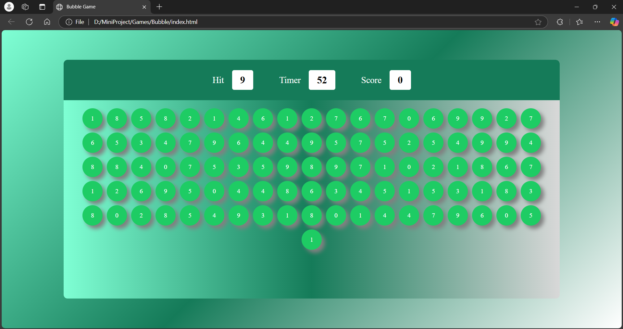Figure 5.1 - Screenshot of Bubble Gameplay

## Candy

Candy is a popular match-three puzzle game. Players must swap adjacent candies to form rows or columns of at least three identical candies. Special candies and combinations add strategic elements, and each level has unique objectives such as clearing jelly or collecting specific candies.

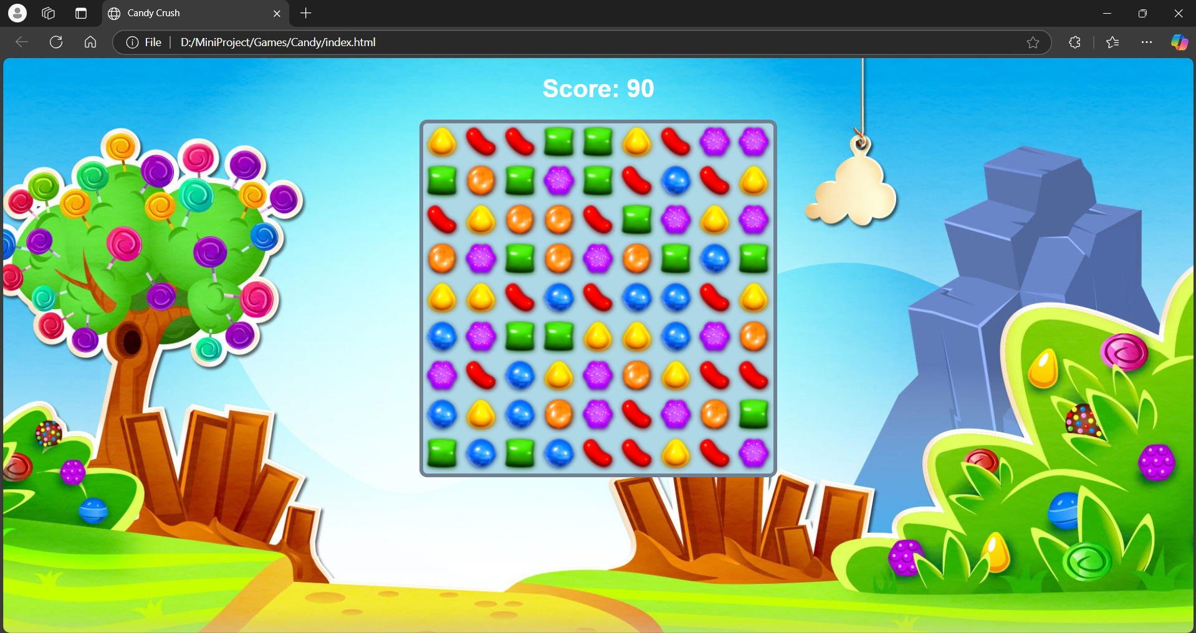Figure 5.2 - Screenshot of Candy Crush Gameplay

## Chess

Chess is a strategic board game played between two players. The objective is to checkmate the opponent’s king while protecting your own. The Game Site version includes features such as hints, undo moves, and different levels of AI difficulty, making it suitable for both beginners and experts.

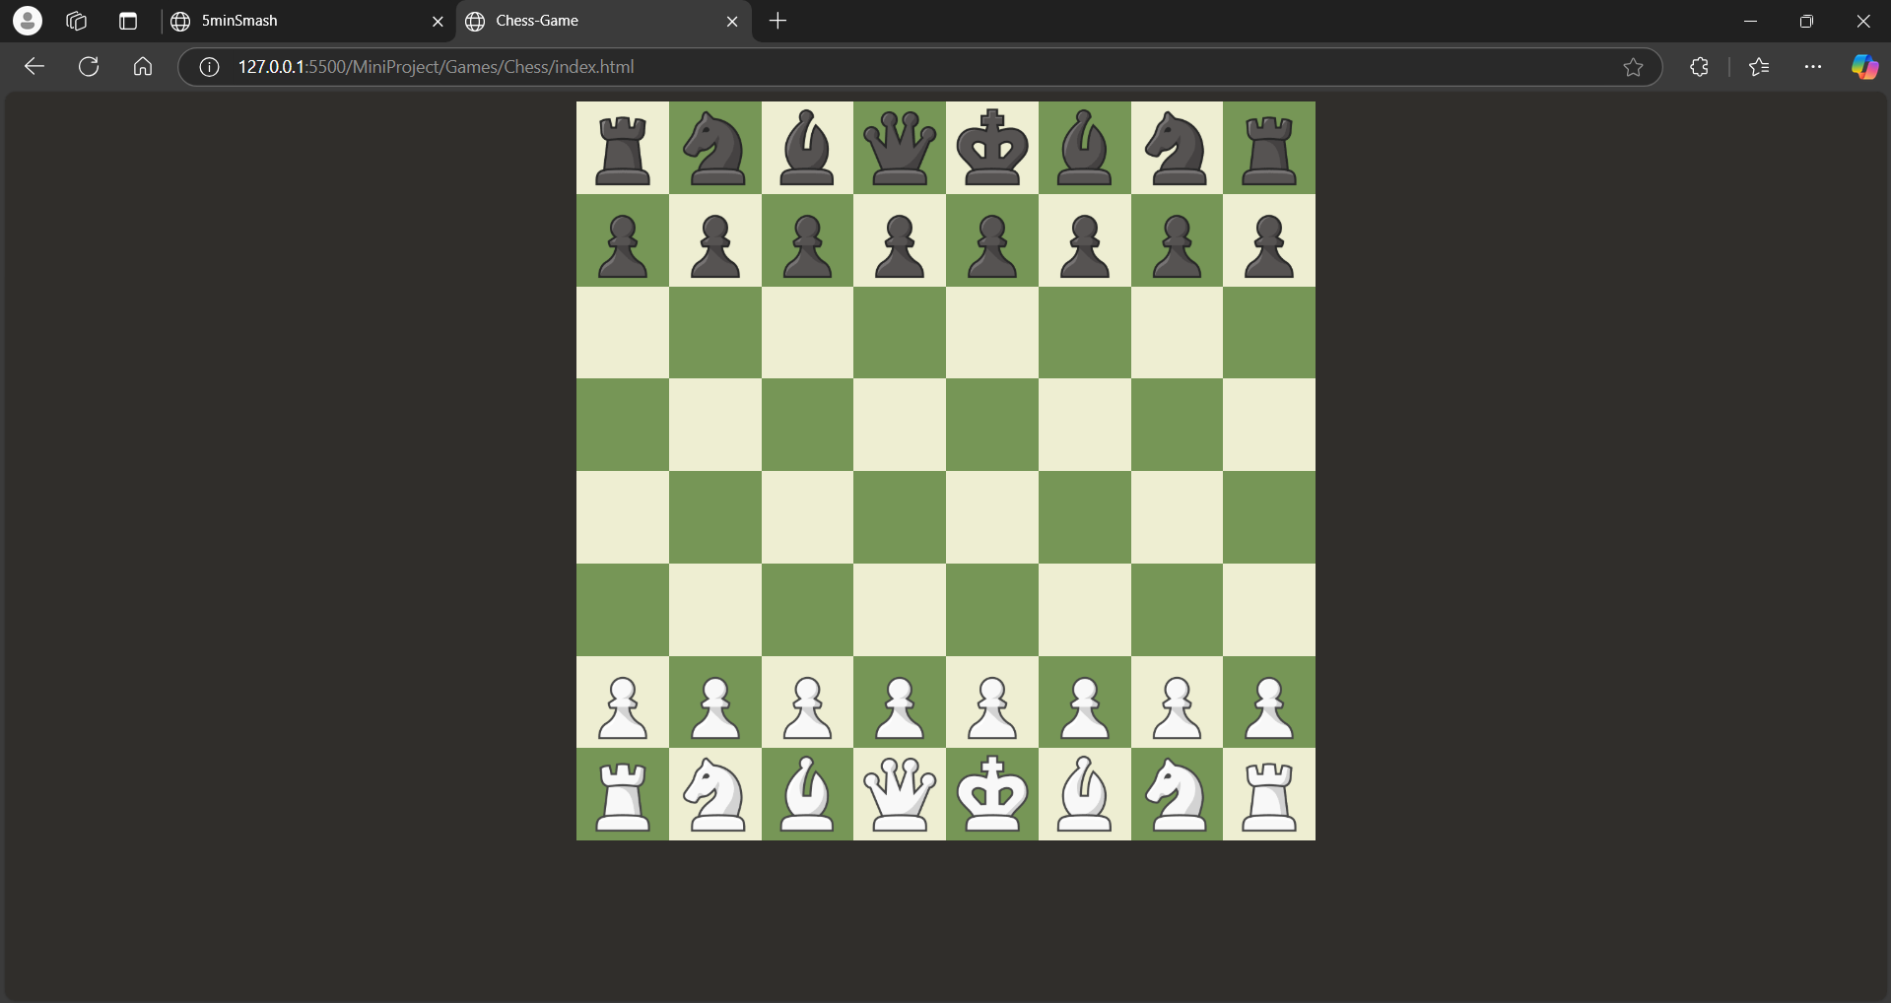Figure 5.3 - Screenshot of Chess Gameplay

## Connect Four

Connect Four is a two-player connection game where the goal is to form a horizontal, vertical, or diagonal line of four of one's discs. Players take turns dropping discs into a grid, requiring strategic planning to block the opponent while forming their line.

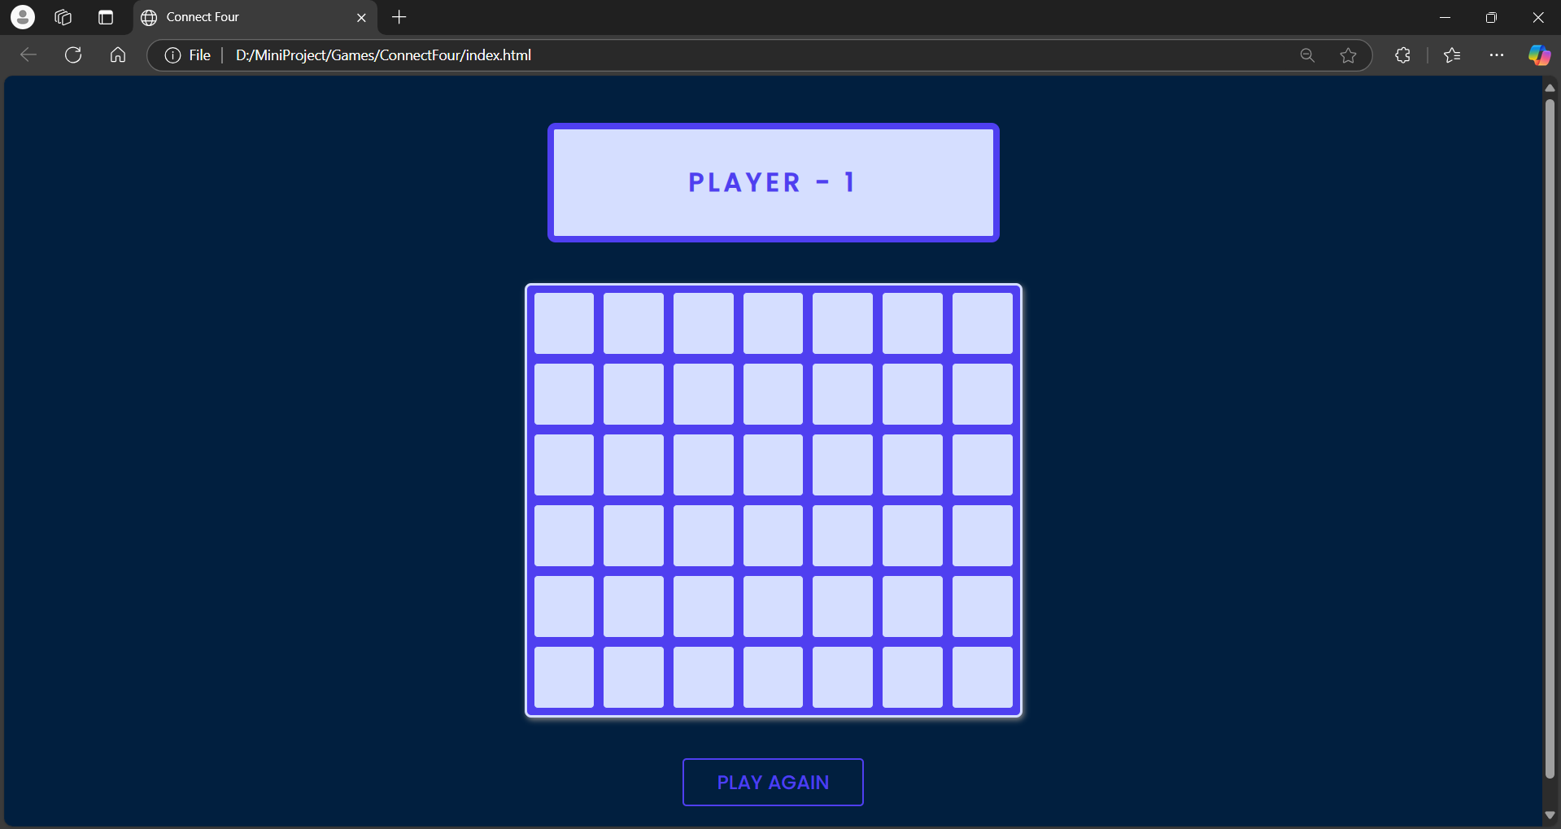Figure 5.4 - Screenshot of Connect Four Gameplay

## Doodle Jump

Doodle Jump is an endless vertical jumping game. Players control a character that continuously jumps upward on platforms, avoiding obstacles and enemies while collecting power-ups. The objective is to achieve the highest score before falling off the screen.

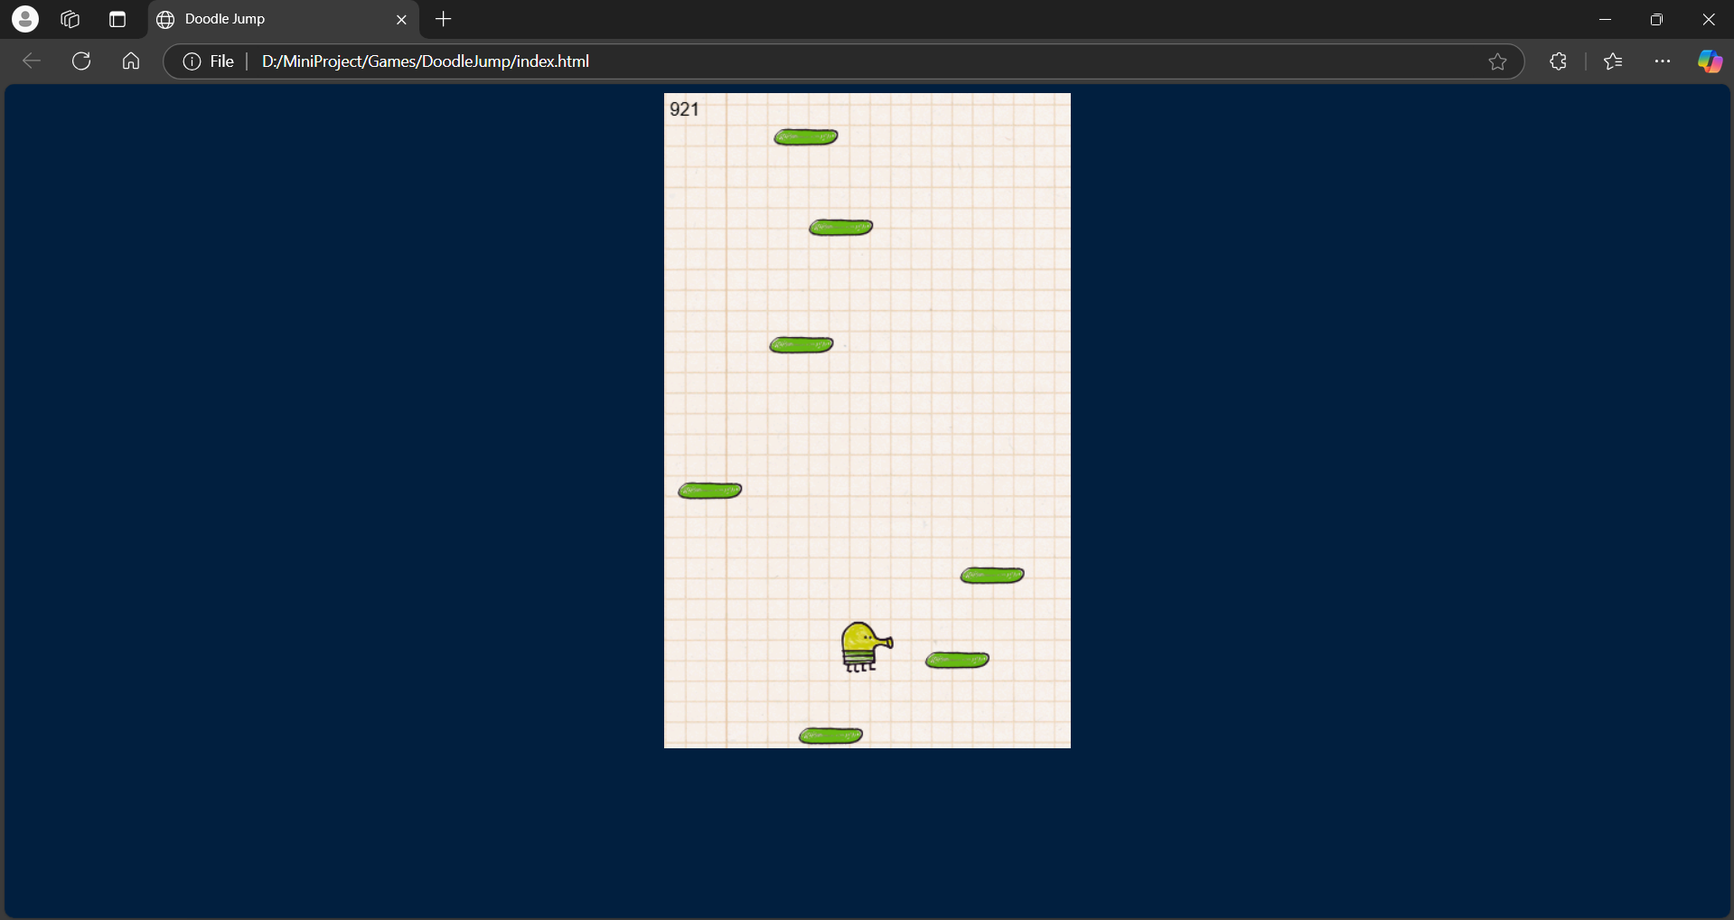Figure 5.5 - Screenshot of Doodle Jump Gameplay

## Flappy Bird

Flappy Bird is an arcade-style game where players navigate a bird through a series of pipes by tapping the screen to keep the bird airborne. The game is simple yet highly challenging due to its precise timing requirements and narrow gaps between pipes.

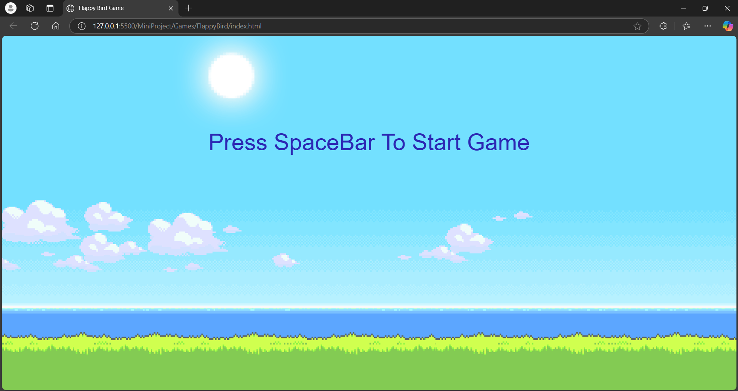Figure 5.6 - Screenshot of Flappy Bird Gameplay

## Rock-Paper-Scissors

Rock-Paper-Scissors is a classic hand game adapted for the digital platform. Players choose rock, paper, or scissors, and the game determines the winner based on traditional rules. The game is designed for quick rounds and includes both player-vs-AI and multiplayer modes.

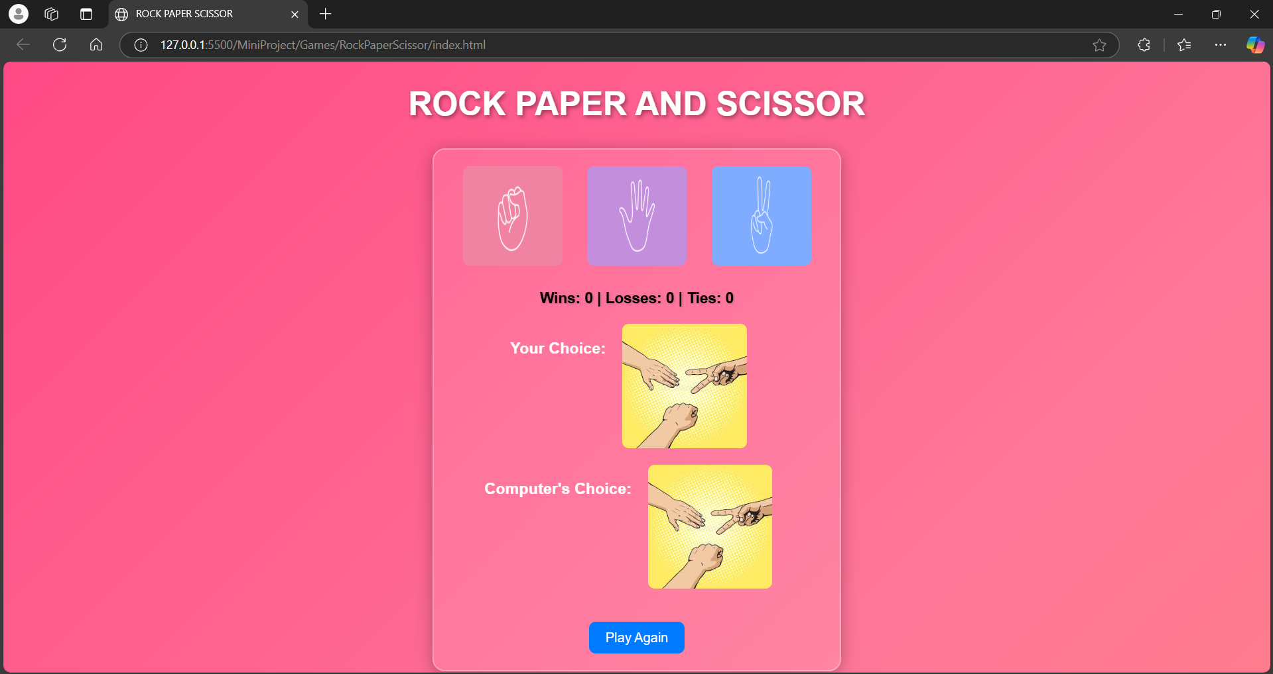Figure 5.7 - Screenshot of Rock-Paper-Scissors Gameplay

## Simon

Simon is a memory game where players must repeat a sequence of colors and sounds generated by the game. The sequences become progressively longer and more complex, challenging players' memory and concentration.

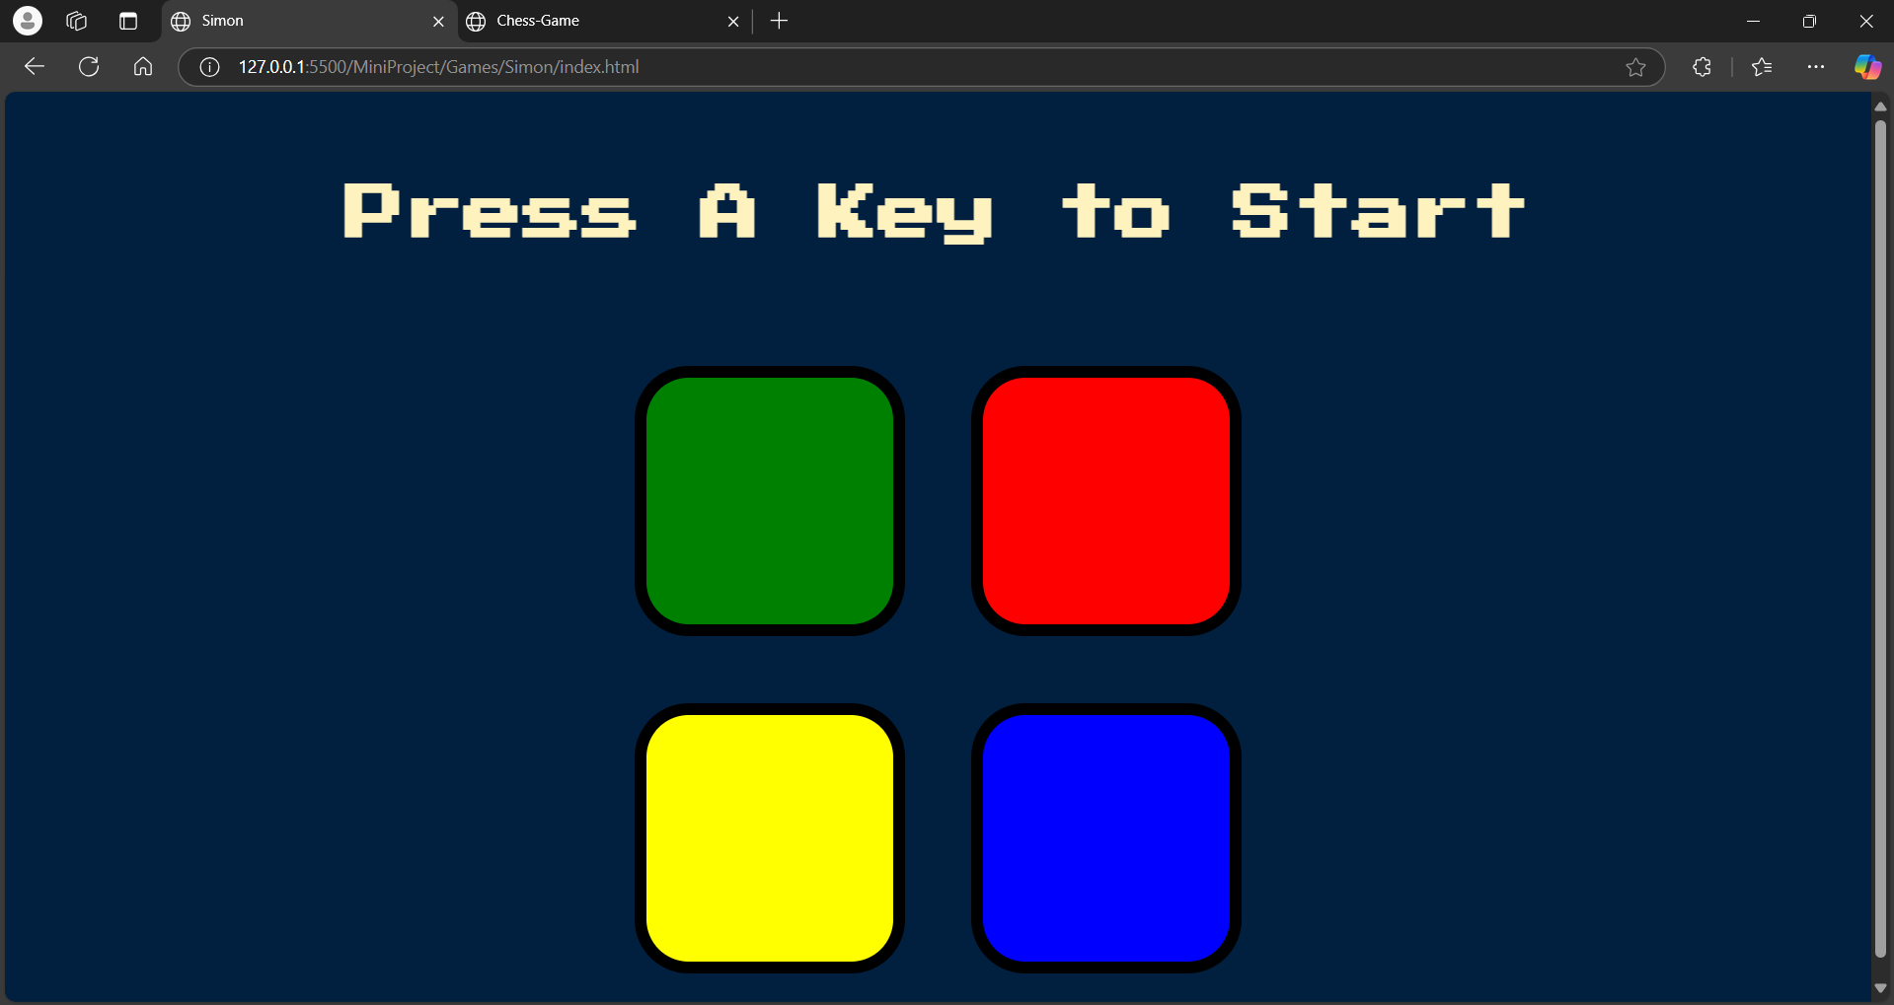Figure 5.8 - Screenshot of Simon Gameplay

## Sudoku

Sudoku is a logic-based number placement puzzle. Players fill a 9x9 grid with digits so that each column, row, and 3x3 sub-grid contains all digits from 1 to 9. The Game Site offers various difficulty levels, catering to both beginners and experienced players.

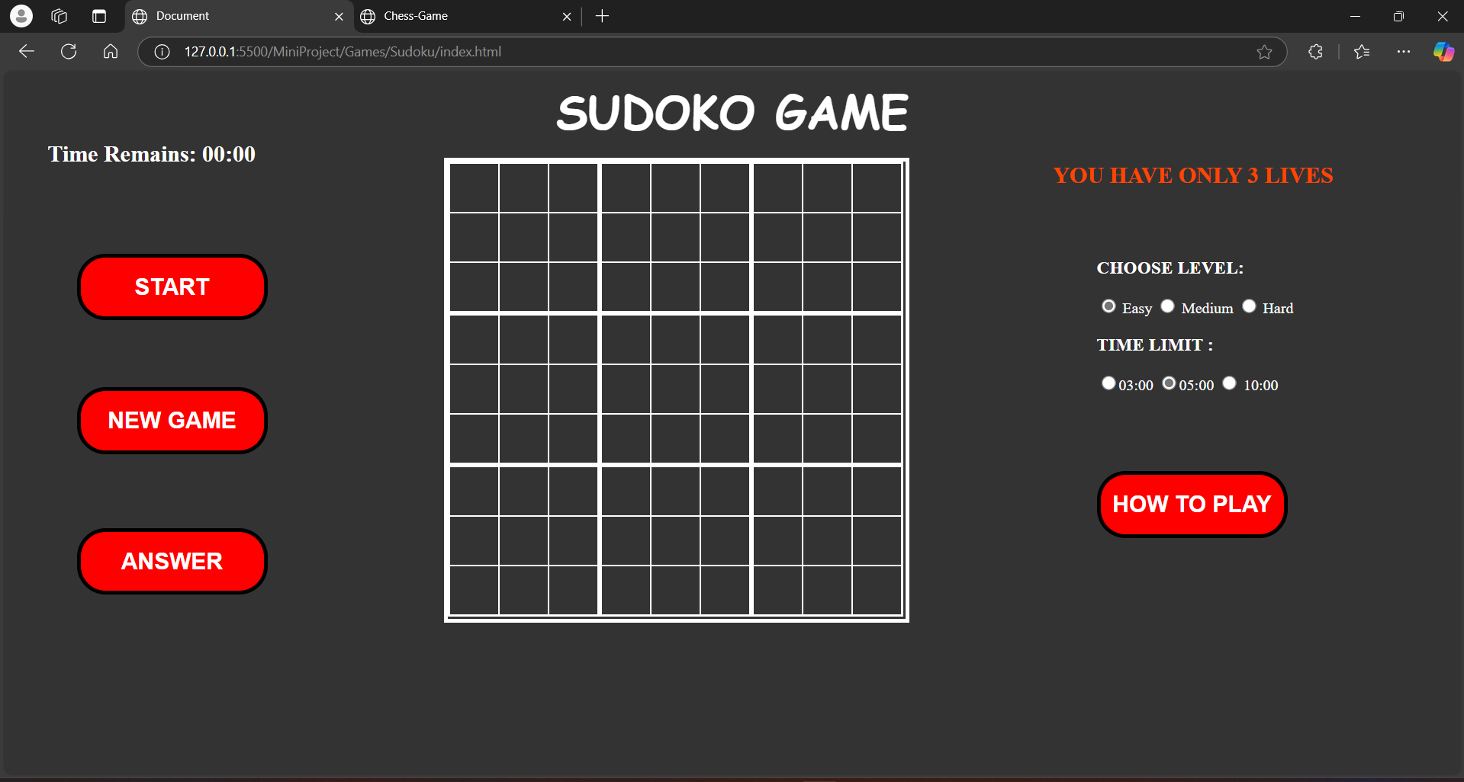Figure 5.9 - Screenshot of Sudoku Gameplay

## Tic-Tac-Toe

Tic-Tac-Toe is a simple strategy game played on a 3x3 grid. Players take turns marking Xs and Os in empty spaces, aiming to form a horizontal, vertical, or diagonal line of three symbols. The game includes player-vs-AI and multiplayer options.

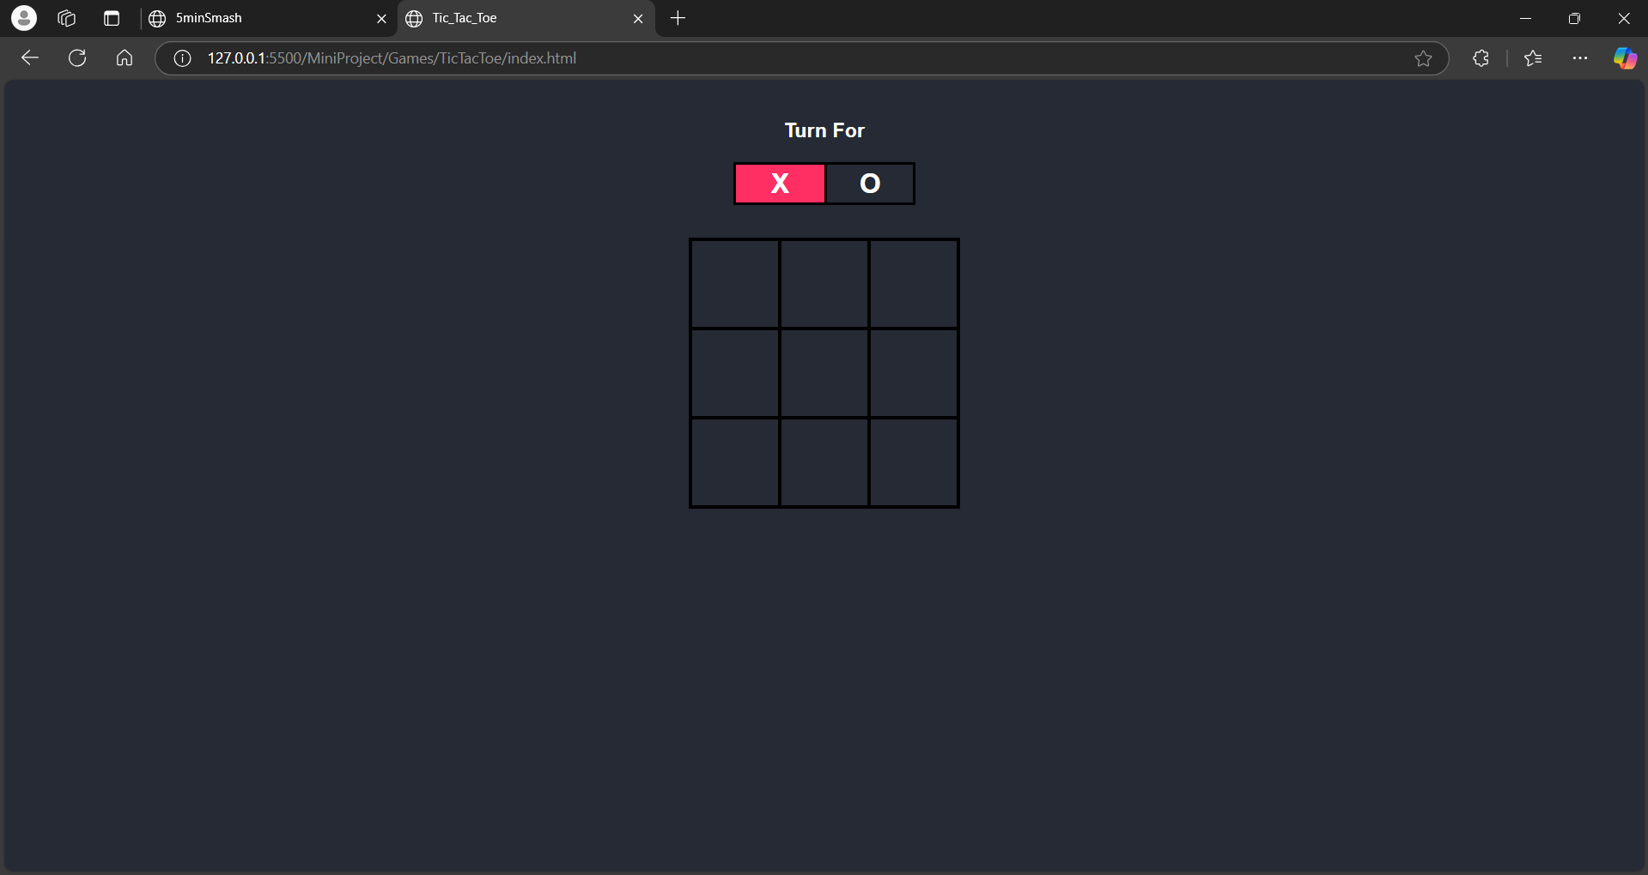Figure 5.10 - Screenshot of Tic-Tac-Toe Gameplay

## Whack Mole

Whack Mole is an action-packed game where players use a virtual hammer to "whack" moles popping up from holes. The goal is to score points by hitting as many moles as possible within a time limit while avoiding decoys.

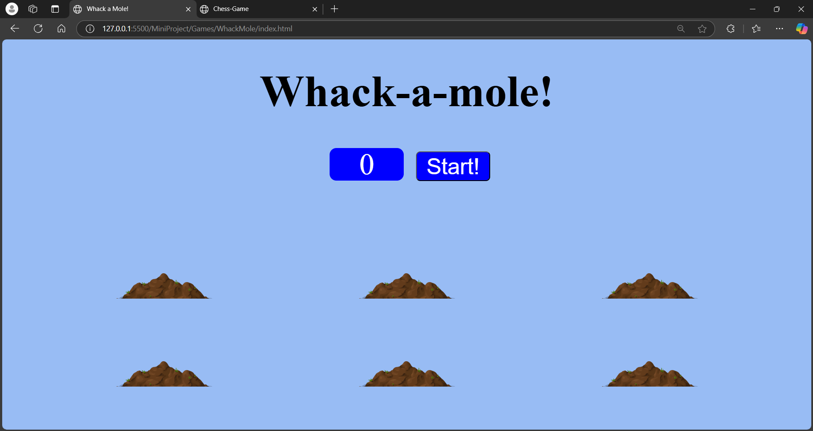Figure 5.11 - Screenshot of Whack Mole Gameplay

# CHAPTER 6 SYSTEM DESIGN

The system design of The Game Site (5 Minute Smash) encompasses the architecture, modules, and interface layouts needed to meet the functional and non-functional requirements of the platform. This chapter provides an in-depth explanation of the design process, covering primary and secondary design phases, and details the user interface design principles adopted.

## Primary Design Phase

The primary design phase defines the high-level structure and core modules of the system. It includes the following key components:

### Modules Design:

* User Authentication Module**:** Handles user registration, login, and secure session management.
* Game Catalog Module**:** Displays all available games, categorized by genre, with detailed descriptions.
* Score Tracking Module**:** Tracks and stores individual player scores in real time.
* Leaderboard Module**:** Displays global and custom leaderboards to encourage competitive gameplay.
* Admin Management Module: Provides administrators with tools to manage games, users, and leaderboards.

### Data Flow:

* Inputs include user credentials, game selections, and scores.
* Outputs include authenticated sessions, launched games, and leaderboard updates.
* Minimizing Inter-Module Dependency: Modules are designed to be loosely coupled, ensuring that changes in one module (e.g., adding new games) do not disrupt the functionality of others (e.g., user authentication).

## Secondary Design Phase

The secondary design phase refines each module and integrates the necessary details for implementation.

### Database Design:

* Users Table**:** Stores user information, including user ID, username, email, and hashed passwords.
* Games Table**:** Maintains game metadata, such as game ID, title, genre, description, and file paths.
* Scores Table**:** Tracks user scores for each game, with fields like user ID, game ID, and score.
* Leaderboards Table**:** Aggregates top scores for global and custom leaderboards.

### API Design:

* RESTful APIs facilitate communication between the frontend and backend.
* Endpoints include:
* /api/login for user authentication.
* /api/games for fetching game details.
* /api/scores for submitting and retrieving scores.
* /api/leaderboards for leaderboard updates.

### Algorithm Design:

* Leaderboard Ranking Algorithm: Sorts and ranks player scores dynamically to update leaderboards in real time.
* Game Matching Algorithm: Suggests games to users based on preferences and playing history.

### User Interface Design

The user interface is designed to be intuitive, visually appealing, and accessible across devices.

#### Interface Layouts:

* Home Page**:** Features a welcoming interface with quick links to popular games and login/registration buttons.
* Game Catalog Page**:** Lists all available games, categorized by genre, with thumbnails and descriptions.
* Gameplay Screen**:** Displays an interactive game environment tailored to the selected game.
* Leaderboard Page**:** Showcases rankings with user avatars, scores, and achievements.

#### Design Principles:

* Consistency**:** Uniform styling across pages, using a common theme and color scheme.
* Responsiveness**:** The interface adapts to various screen sizes, ensuring usability on desktops, tablets, and smartphones.
* Accessibility**:** Includes features such as keyboard navigation and support for screen readers to cater to users with disabilities.
* Minimalism**:** Simplified layouts with clear calls to action, reducing cognitive load for users.
* Prototype Tools:
* Wireframes and mockups are created using tools like Figma to visualize the user journey before implementation.

## 6.3 Database Design

The database design for **The Game Site (5 Minute Smash)** is central to managing user data, game metadata, scores, and leaderboard rankings. A robust database ensures seamless interactions between various components of the system, enabling scalability and efficient data management.

### Database Overview

The database is structured using a relational model to maintain organized and accessible data. It includes the following core entities:

* **User**: Stores user credentials, profiles, and preferences.
* **Game**: Maintains metadata for all available games, such as titles, genres, and descriptions.
* **Score**: Records user performance during gameplay.
* **Leaderboard**: Tracks top scores and rankings for each game.
* **Category**: Groups games into various genres for easy navigation.

### Entity-Relationship Diagram

The database design is visualized through the Entity-Relationship (ER) diagram shown below. This diagram identifies the key entities, their attributes, and the relationships among them.

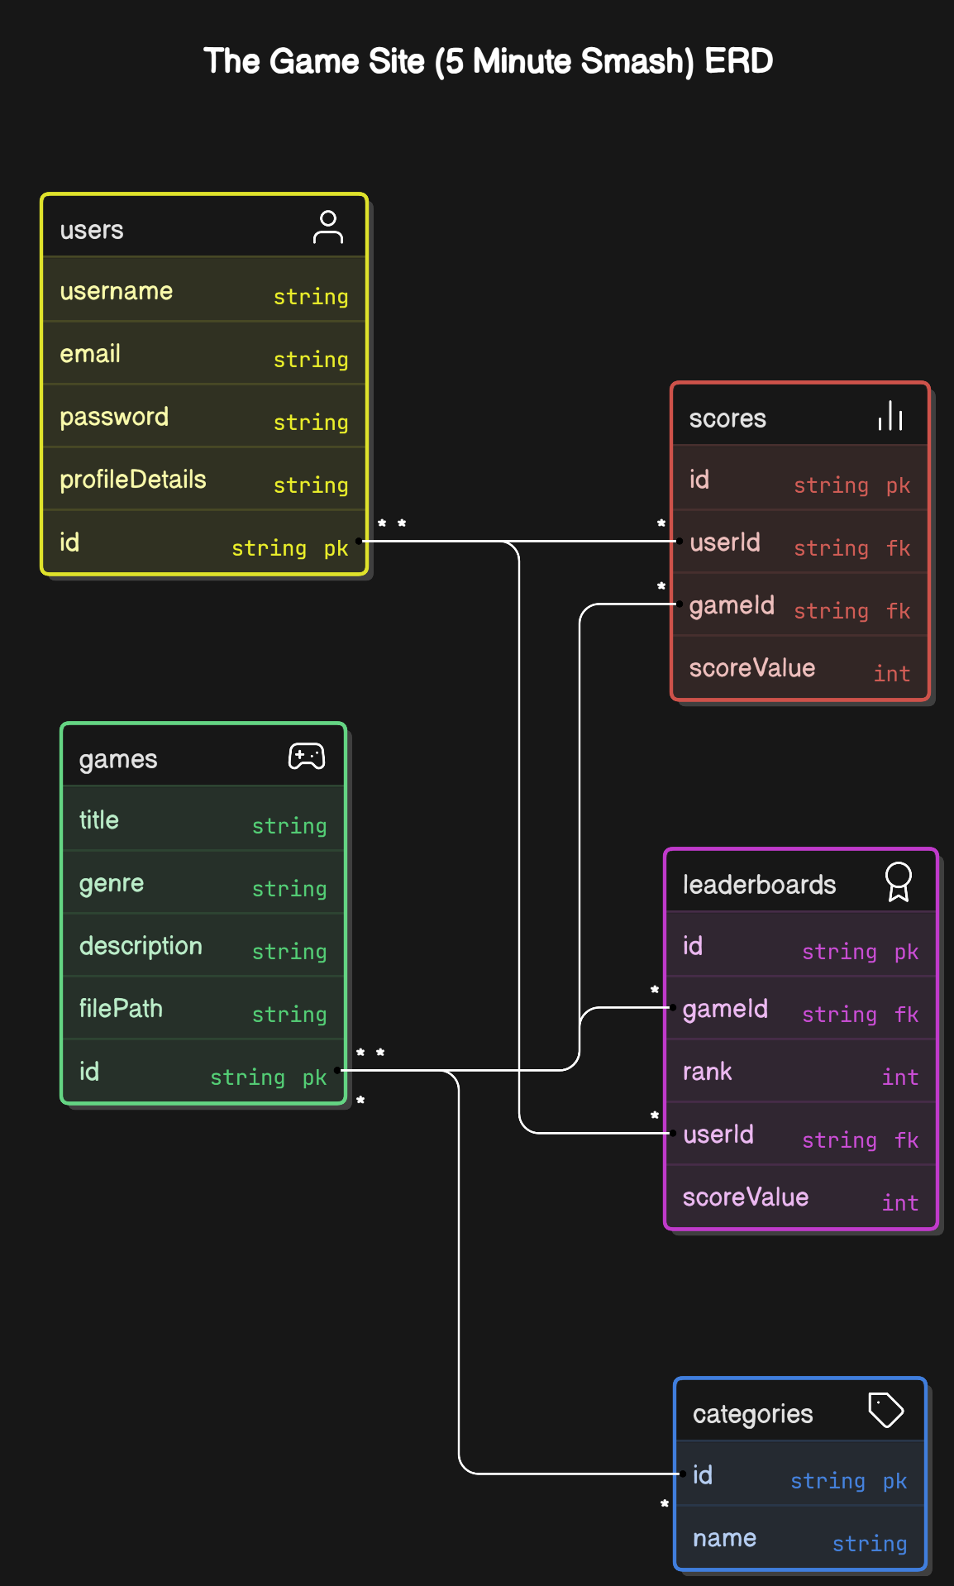Figure 6.1: Entity-Relationship Diagram for The Game Site (5 Minute Smash)

The ER diagram highlights the following relationships:

* A **User** can play multiple **Games**, and each gameplay session is associated with a **Score**.
* Each **Game** belongs to one or more **Categories**.
* Scores are used to update global and custom **Leaderboards**, linking a user’s performance to their ranking in a specific game.

### Database Tables

The key database tables derived from the ER diagram include:

#### Users Table:

* Attributes: User ID (Primary Key), Username, Email, Password, Profile Details.

#### GamesTable:

* Attributes: Game ID (Primary Key), Title, Genre, Description, File Path.

#### Scores Table:

* Attributes: Score ID (Primary Key), User ID (Foreign Key), Game ID (Foreign Key), Score Value.

#### Leaderboards Table:

* Attributes: Leaderboard ID (Primary Key), Game ID (Foreign Key), Rank, User ID (Foreign Key), Score Value.

#### CategoriesTable:

* Attributes: Category ID (Primary Key), Name.

### Data Flow and Security

The database is designed to ensure:

* Data Integrity: Proper use of primary and foreign keys to maintain consistency.
* Scalability: The modular structure supports adding new games or user features without disrupting existing data.
* Security: Sensitive data, such as passwords, is stored using encryption, and access to database operations is controlled through secure APIs.

The system design ensures that The Game Site (5 Minute Smash) is modular, scalable, and user-friendly. By carefully structuring the primary and secondary design phases and adhering to interface design principles, the platform delivers a seamless and engaging experience for both users and administrators.

# CHAPTER 7 ARCHITECTURE

The architecture of The Game Site (5 Minute Smash) is designed to ensure a scalable, secure, and efficient platform capable of delivering seamless gaming experiences. This chapter outlines the architecture pattern, its components, and their interactions to achieve the functional and non-functional requirements of the platform.

## Layered Architecture

The system follows a three-tier layered architecture pattern. This design separates the platform into three distinct layers, each responsible for specific tasks, ensuring modularity and ease of maintenance.

### Presentation Layer

The presentation layer is the user-facing interface that facilitates interaction between the platform and its users.

* Responsibilities:
* Displays user interfaces, such as login pages, game catalogs, gameplay screens, and leaderboards.
* Handles user inputs like game selections, score updates, and navigation requests.
* Communicates with the business logic layer to fetch and display data.
* Technologies Used:
* Frontend: React.js for building responsive and interactive user interfaces.
* Styling: CSS3 and frameworks like Bootstrap for consistent design.

### Business Logic Layer (Application Layer)

The business logic layer processes the data received from the presentation layer and applies the platform's core functionalities.

* Responsibilities:
* Processes user authentication, including login and registration.
* Manages game selection and launches gameplay sessions.
* Handles score calculations and updates.
* Executes leaderboard ranking algorithms.
* **Technologies Used:**
* Backend Framework: Node.js for efficient server-side operations.
* RESTful APIs: Facilitates communication between the presentation and data access layers.

### Data Access Layer (Persistence Layer)

The data access layer manages the storage and retrieval of persistent data.

* Responsibilities:
* Stores user data, including profiles, login credentials, and preferences.
* Maintains game metadata, such as genres, descriptions, and assets.
* Tracks and retrieves player scores and leaderboard rankings.
* Technologies Used:
* Database**:** MongoDB for flexible and scalable data storage.
* Security**:** Implements encryption for sensitive user data to ensure privacy and compliance.

### Data Flow

The layered architecture ensures smooth data flow between the platform's components:

* User Interaction:
* Users interact with the presentation layer via a web browser.
* Inputs like login credentials or game selections are processed and forwarded to the business logic layer.
* Processing Logic:
* The business logic layer validates user inputs, processes requests, and communicates with the data access layer to fetch or store data.
* Data Management:
* The data access layer retrieves requested data (e.g., user profiles, game information) and updates scores or leaderboard rankings.
* Data is sent back through the business logic layer to the presentation layer for display.

### System Components

* Frontend:
* Provides an interactive, user-friendly interface.
* Handles real-time updates like score tracking and game progress.
* Backend:
* Manages all server-side processes and APIs for data communication.
* Executes business logic, including game algorithms and leaderboard updates.
* Database:
* Stores all persistent data, ensuring accessibility and consistency.
* Optimized for real-time queries to handle high traffic during gameplay.

## Advantages of Layered Architecture

* + 1. Modularity**:** Each layer operates independently, making updates or bug fixes easier.
    2. Scalability**:** The architecture supports the addition of new features or games without affecting existing functionality.
    3. Security**:** Sensitive user data remains protected due to clear separation of layers and secure communication protocols.
    4. Maintenance**:** Clear separation of concerns ensures efficient troubleshooting and debugging.

The architecture of The Game Site (5 Minute Smash) is crafted to deliver a robust and efficient gaming platform. By leveraging the layered approach, the system ensures flexibility, scalability, and a seamless user experience.

# CHAPTER 8 SCREENSHOTS AND DEMONSTRATIONS

## Login Page

This section includes a screenshot of the Login Page, showcasing its layout, fields for username and password, and additional features such as the "Forgot Password" link and "Sign Up" option.

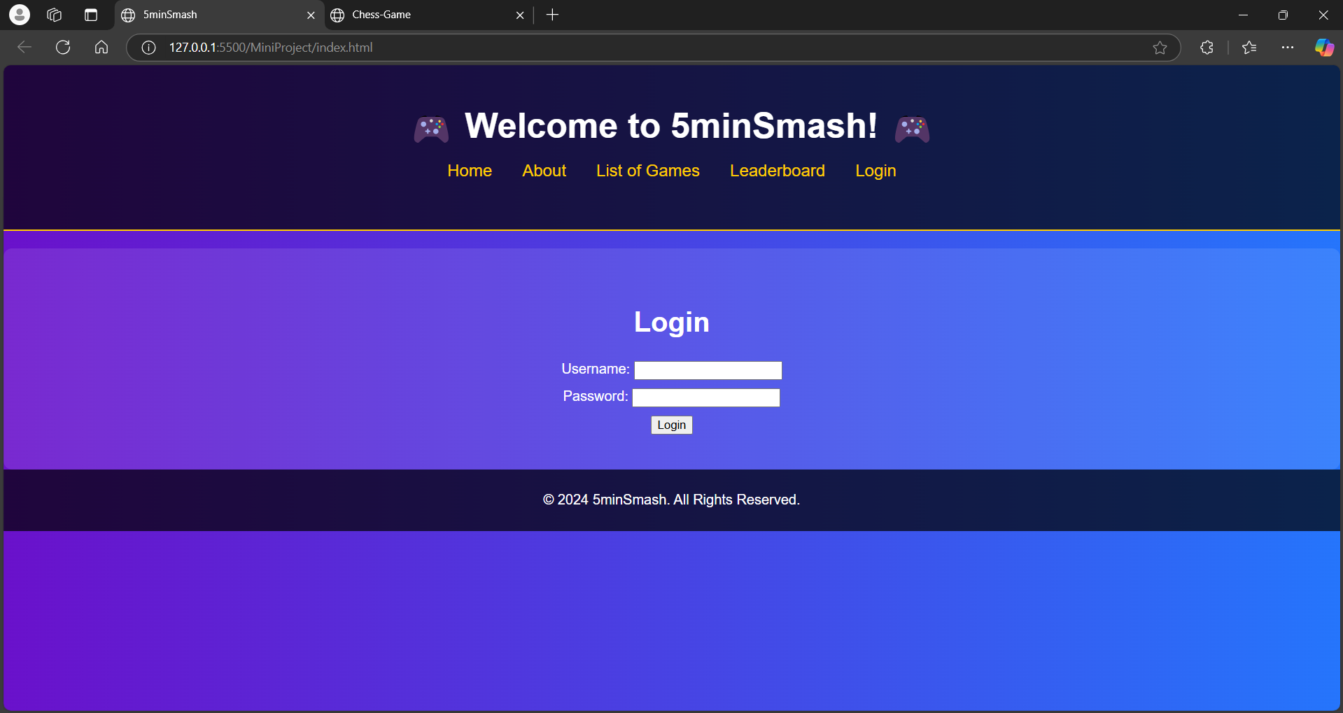Figure 8.1 - Login Page

## Game Catalog

The Game Catalog showcases all the available games, complete with thumbnails, descriptions, and filters for genres.

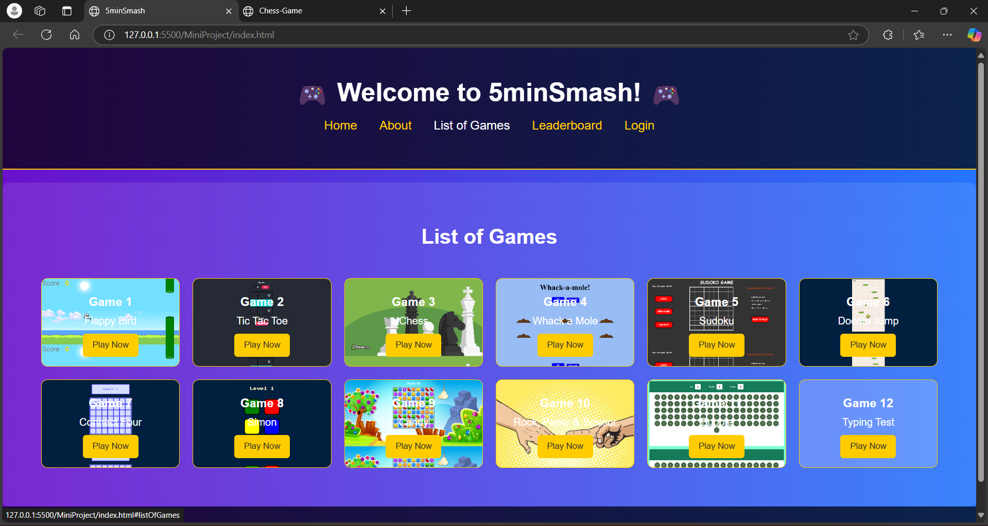Figure 8.2 - Game Catalog

## Gameplay Interface

Screenshots here demonstrate the in-game experience, including key interface elements and user interactions.

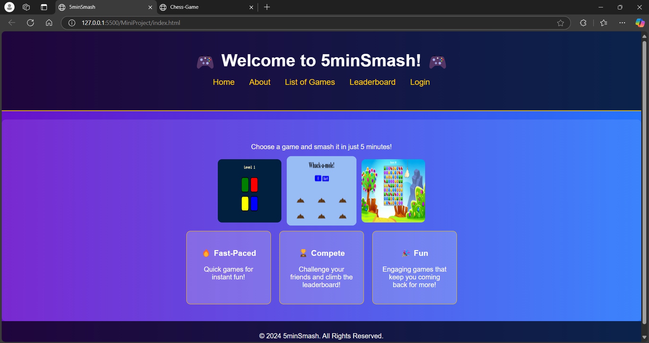Figure 8.3 - Gameplay Interface

## Leaderboard Page

This section highlights the Leaderboard Page, showing rankings, scores, and filtering options.

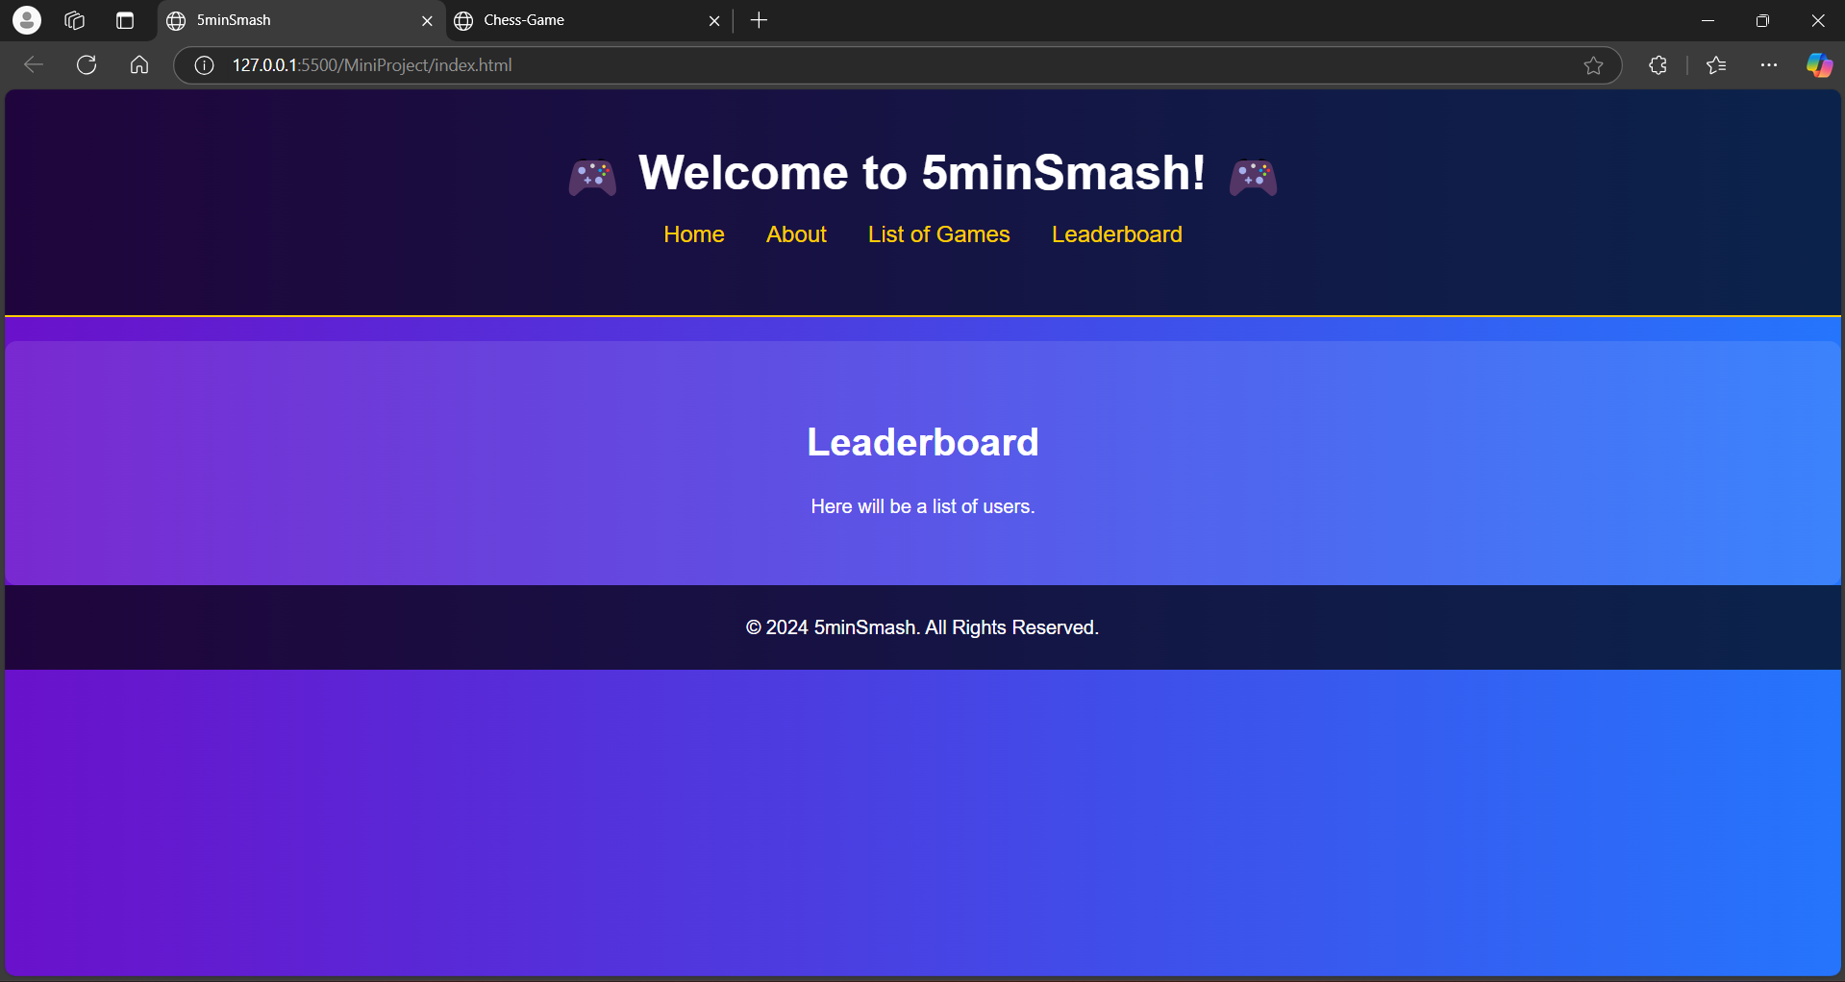Figure 8.4 - Leaderboard Page

## Bubble Gameplay

A demonstration of the gameplay experience for Bubble, including interface details and visual design.

Figure 8.5 - Bubble Gameplay

## Candy Gameplay

Screenshots of Candy Crush gameplay, highlighting the grid of candies and special effects for matches.

Figure 8.6 - Candy Crush Gameplay

## Chess Gameplay

Screenshots showcasing Chess gameplay, including board setup, player options, and AI difficulty settings.

Figure 8.7 - Chess Gameplay

## Connect Four GAMEPLAYS

Connect Four gameplay screenshots demonstrating the drop disc mechanics and the win/loss interface.

Figure 8.8 - Connect Four Gameplay

## Doodle Jump Gameplay

Doodle Jump's endless platformer interface, showing character movement, obstacles, and score tracking.

Figure 8.9 - Doodle Jump Gameplay

## Flappy Bird Gameplay

A screenshot of Flappy Bird gameplay, showing the bird navigating through pipes and score updates.

Figure 8.10 - Flappy Bird Gameplay

## Rock-Paper-Scissors Gameplay

Screenshots of the Rock-Paper-Scissors interface, featuring player-vs-computer and multiplayer options.

Figure 8.11 - Rock-Paper-Scissors Gameplay

## Simon Gameplay

A demonstration of Simon gameplay with screenshots showing the sequence of lights and player inputs.

Figure 8.12 - Simon Gameplay

## Sudoku Gameplay

Screenshots illustrating Sudoku gameplay, with examples of grids at various difficulty levels.

 Figure 8.13 - Sudoku Gameplay

## Tic-Tac-Toe Gameplay

Tic-Tac-Toe gameplay screenshots demonstrating player turns, AI moves, and the win/lose/draw interface.

Figure 8.14 - Tic-Tac-Toe Gameplay

## Whack Mole Gameplay

Screenshots of Whack Mole gameplay, highlighting the fast-paced interaction and scorekeeping.

Figure 8.15 - Whack Mole Gameplay

# CHAPTER 9 CONCLUSION

The development and implementation of **The Game Site (5 Minute Smash)** serve as a pivotal step in redefining the landscape of online gaming. By unifying diverse games into a single, scalable, and user-friendly platform, this project addresses the prevailing challenges of fragmentation, limited user engagement, and cross-platform compatibility that have historically affected gamers and developers.

The platform leverages cutting-edge technologies, including React.js for an intuitive frontend, Node.js for efficient backend processing, and MongoDB for scalable data storage. Features such as real-time score tracking, secure user authentication, and multiplayer support demonstrate the robustness and versatility of the system. Additionally, testing methodologies ensured reliability, security, and high performance under various conditions.

Feedback from user trials validated the platform’s appeal and functionality, highlighting its potential to attract a diverse user base ranging from casual gamers to competitive players. The seamless integration of games such as Chess, Flappy Bird, Sudoku, and Candy Crush has been particularly well-received.

Looking forward, **The Game Site (5 Minute Smash)** presents opportunities for significant enhancements. Incorporating AR/VR technologies will provide immersive gaming experiences, while AI-driven personalization and advanced analytics can deepen user engagement and retention. Expanding the platform’s game catalog and integrating social gaming elements will further its appeal to a global audience.

In conclusion, **The Game Site (5 Minute Smash)** successfully achieves its objectives, setting the foundation for continued innovation in the online gaming industry. Its adaptability and scalability ensure relevance in a rapidly evolving technological landscape.

# CHAPTER 10 REFERENCES

* Rao, A., et al., "In-band Full-duplex Radio," International Journal of Applied Engineering Research, 2019.
* Lee, H., et al., "Optimal Beamforming Designs," IEEE Transactions on Wireless Communications, 2015.
* Clancy, T., "Achievable Capacity under the Interference Temperature Model," IEEE INFOCOM, 2007.
* Chen, J., "Cloud Gaming Architecture and Benefits," Journal of Gaming Technology Trends, 2020.
* Smith, A., et al., "AI in Multiplayer Gaming: Enhancing User Engagement," Gaming AI Conference Proceedings, 2021.
* Brown, P., "Scaling Multiplayer Gaming Platforms," Modern Computing Journal, 2022.
* Williams, R., "WebSocket Protocols for Real-time Communication," Journal of Software Engineering, 2020.
* Tanaka, Y., et al., "Gamification in Modern Applications," Digital Innovation Review, 2018.
* Wilson, K., "React.js Best Practices for Scalable Web Apps," Web Development Quarterly, 2021.
* Green, L., "Enhancing Data Security in Online Platforms," Cybersecurity Today, 2022.